**SECTION B TERMINOLOGY 10 MARKS**

Select the most appropriate biological term for each question.

**DO NOT** use abbreviations.

1. Type of transport where materials are transported against a diffusion gradient

_________________________________________

1. Breakdown of a glucose molecule in the cytoplasm of a cell

_________________________________________

1. The nutrient group that contains carbon, hydrogen, oxygen and nitrogen is:

_________________________________________

44. If this vitamin is lacking, rickets may develop

_________________________________________

1. An organic catalyst that speeds up the rate of reactions

_________________________________________

46. Chemical molecule that takes the protein code instructions from the nucleus to the ribosomes

_________________________________________

1. What structures in the cell are responsible for spindle formation

_________________________________________

1. Name of stomach enzyme activated by hydrochloric acid

_________________________________________

1. Example of a sugar molecule where two simple units have joined together

_________________________________________

1. The major blood vessel, which carries blood from the gut to the liver.

______________ ___________________________

**END OF SECTION B**

**SECTION C SHORT ANSWERS 60 MARKS**

Answer **ALL** the questions in the spaces provided.

1. (11 marks)

a) Diagram of a human cell. Name the cell structures represented by labels A-H.

Glycogen granules

Nucleus

Vacuoles forming

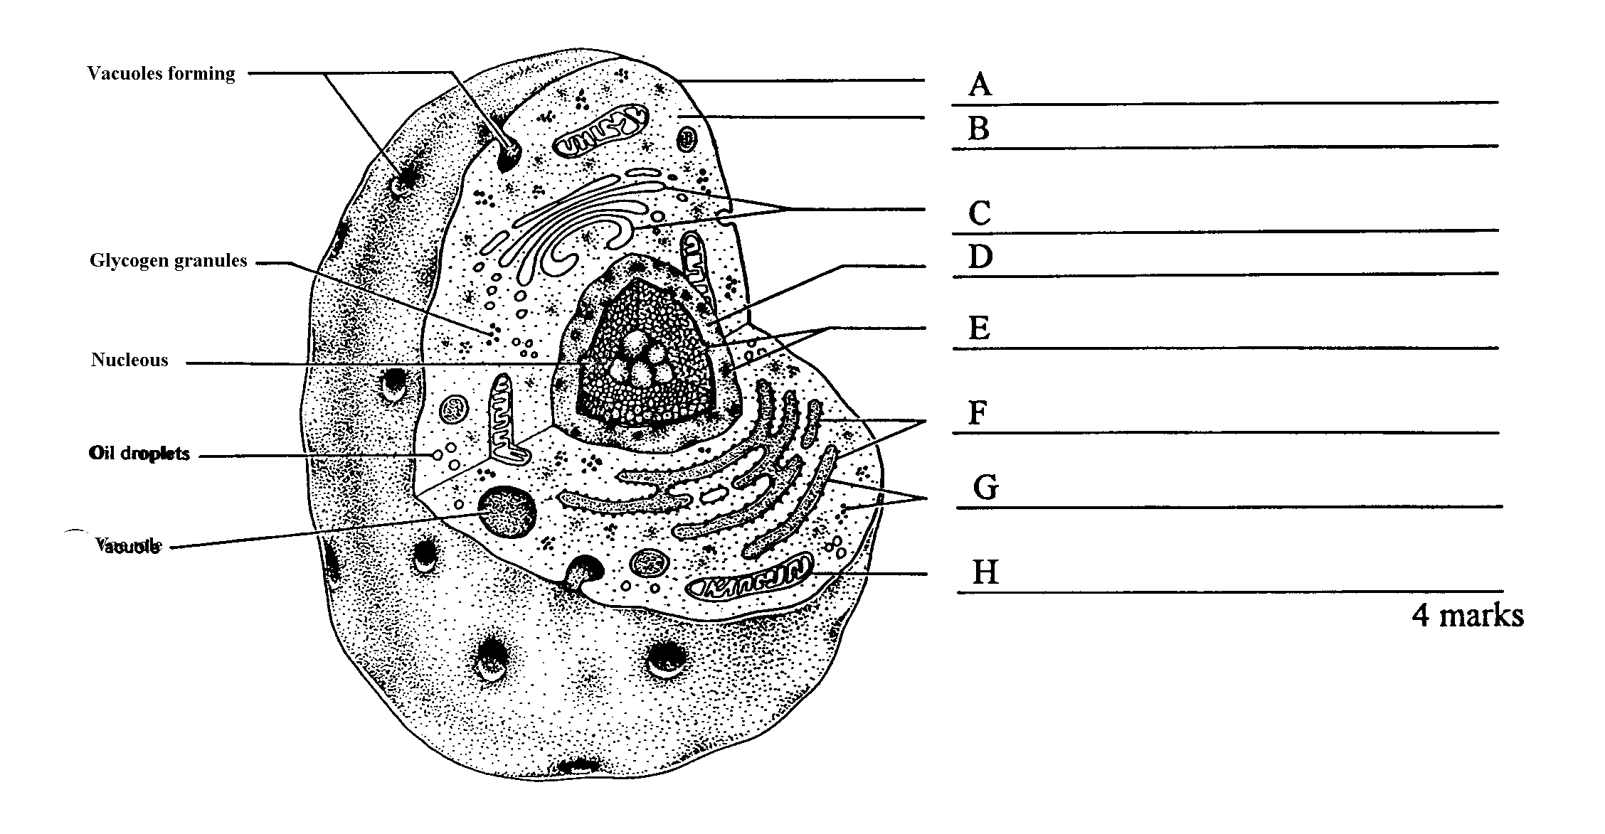

Vacules

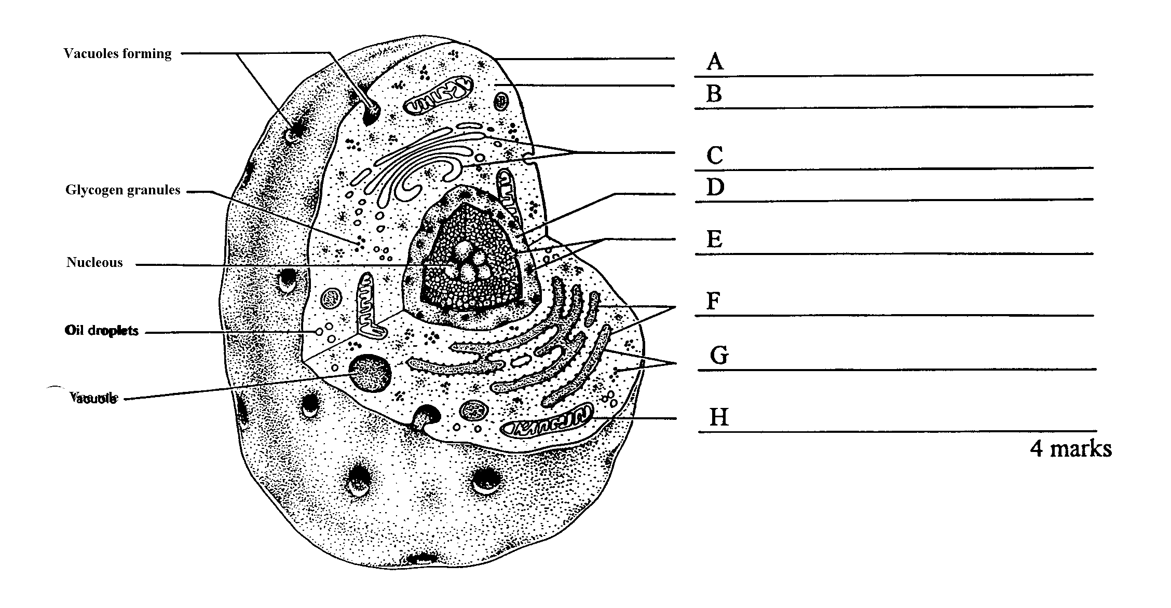

(dot)

b) In the diagram above, what is the function of:

(Dots)

Vacuole

Oil droplet

Structure C

Structure G

(2 marks)

c) (i) If this was a hard working muscle cell, name the immediate source of energy it would use.

(1 mark)

1. How is this molecule changed to allow the release of energy for use in muscle contraction?

(1 mark)

1. Explain how DNA can control protein production when it never leaves the nucleus.

(3 marks)

1. The following diagrams show different stages of the mitotic division of one cell.

(4 marks)

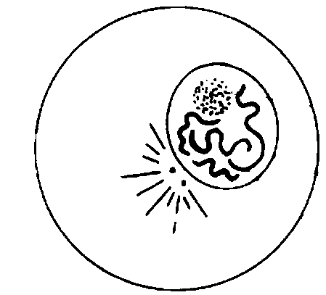

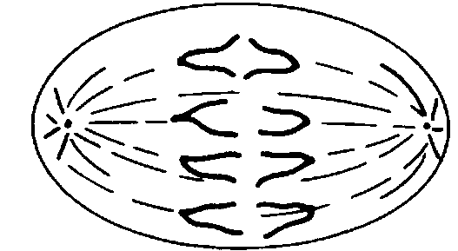

A

**B**

**C**

**D**

**E**

**F**

**G**

**H**

**I**

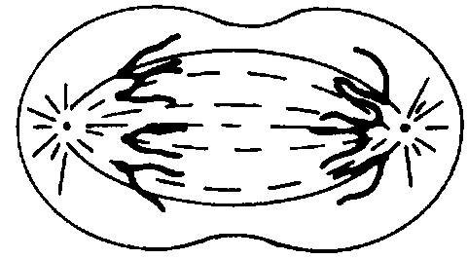

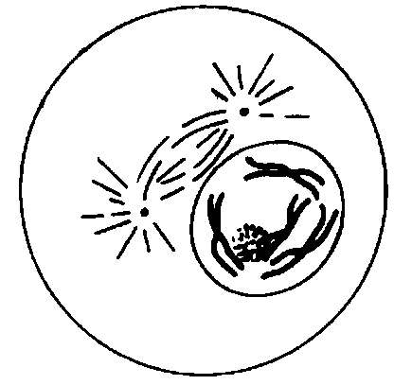

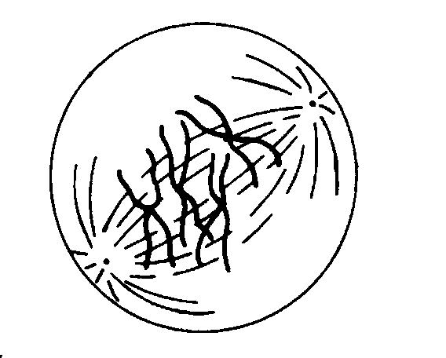

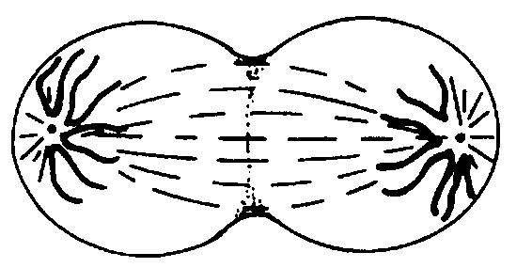

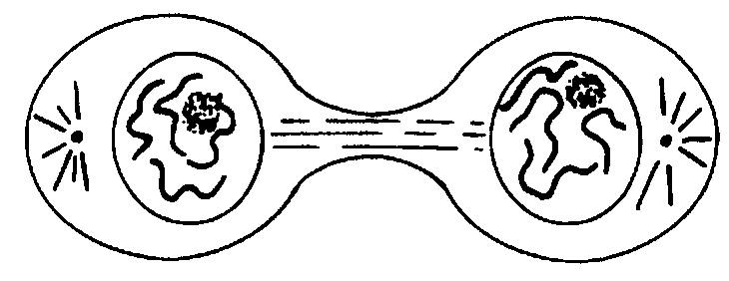

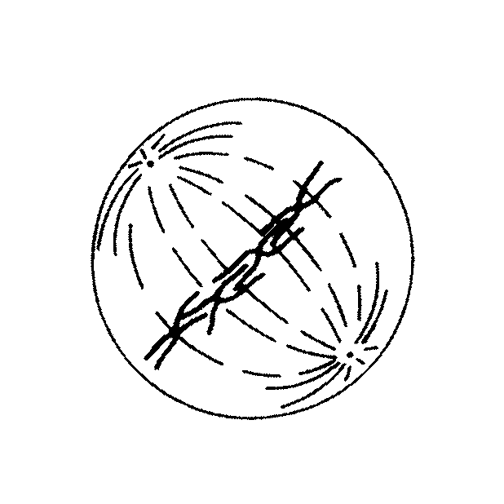

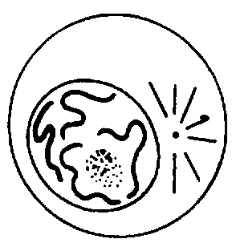

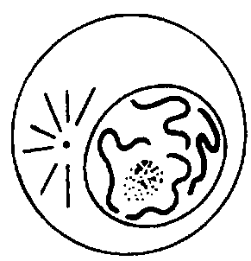

(a)

|  |  |
| --- | --- |
| Stage | Briefly describe what is happening in the cell at this stage |
| B |  |
| D |  |
| E |  |

(3 marks)

(b) Using the letters A- I, identify when the cell is at the stage of mitosis called:

i. Metaphase ii.. Early anaphase

(1 mark)

1. (9 marks)
2. Using the heart diagram match the function with the appropriate letter in the table below.

**A**

**N**

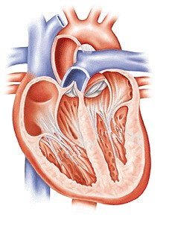

**M**

**B**

**L**

**C**

**K**

**J**

**I**

###### D

**H**

**G**

**E**

**F**

|  |  |
| --- | --- |
|  | Returns deoxygenated blood back to the heart. |
|  | Prevents blood from flowing back into the right atrium. |
|  | Blood is directed to the left lung though this structure. |
|  | Prevents atrioventricular valve from turning inside out. |
|  | Ensures that blood does not flow back into the ventricles. |
|  | Brings oxygenated blood back to the heart. |

(6 marks)

1. Use large red arrows to clearly indicate the direction of flow of oxygenated blood through

the heart and its vessels. (1 mark)

(c) Describe two ways by which carbon dioxide can be carried in the blood.

(I)

(II)

(2 marks)

1. (8 marks)

The heart walls contain muscle cells that are able to contract.

(a) Name the type of muscle cells. _______________________________ (1 mark)

(b) Name the type of organelle found in the cells that is directly responsible for the release of energy for the activity of these cells.

_________________________________________________________ (1 mark)

(c) A cell was observed under a microscope that was had two ocular lenses as well as 5x, 20x and 60x objectives. Fill in the missing spaces to complete this table:

|  |  |  |  |
| --- | --- | --- | --- |
| Ocular | Objective | Magnification | Field of view |
| 10x | 5x | 50 |  |
| 15x | 20x | 300 | 300 micrometers |
| 15x | 60x | 900 |  |

(1 mark)

(d) If the cell was 0.0l mm wide, how wide would it be in micrometres?

_________________________________________________________ (1 mark)

(e) Using the following diagram, explain what is happening in diagrams A to C.

_________________________________________________________________

_________________________________________________________________

_________________________________________________________________

_________________________________________________________________

_________________________________________________________________

_________________________________________________________________

_________________________________________________________________

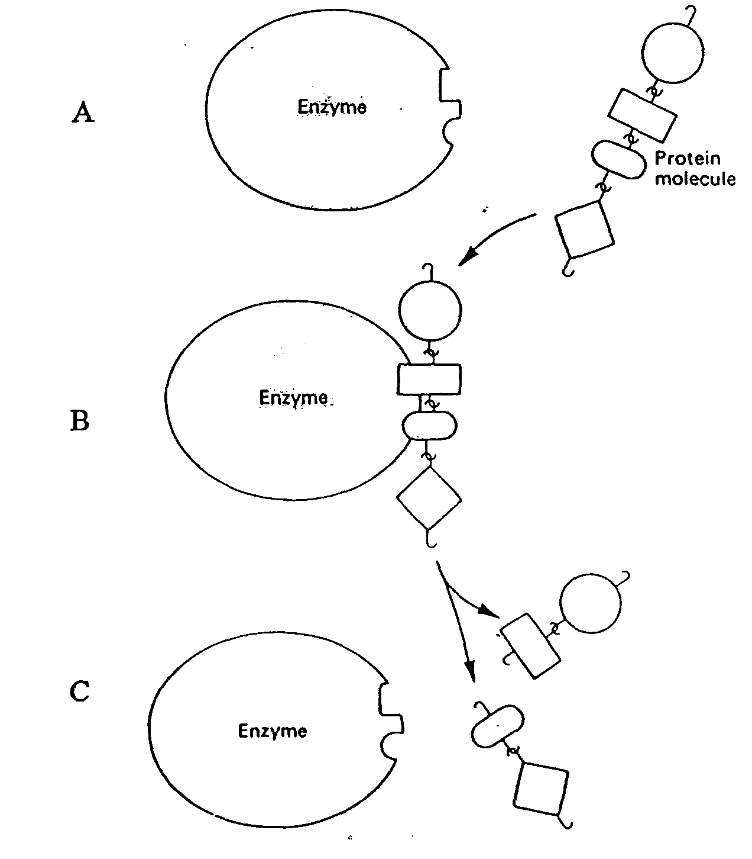

Enzyme

Enzyme

Enzyme

Protein molecule

(3 marks)

(f) There are a number of factors that might affect the speed of this reaction.

List any two:

i.

ii.

(1 mark)